Taryn Crawford

Michael Cassens

MART 120

11 September 2021

Learning Style

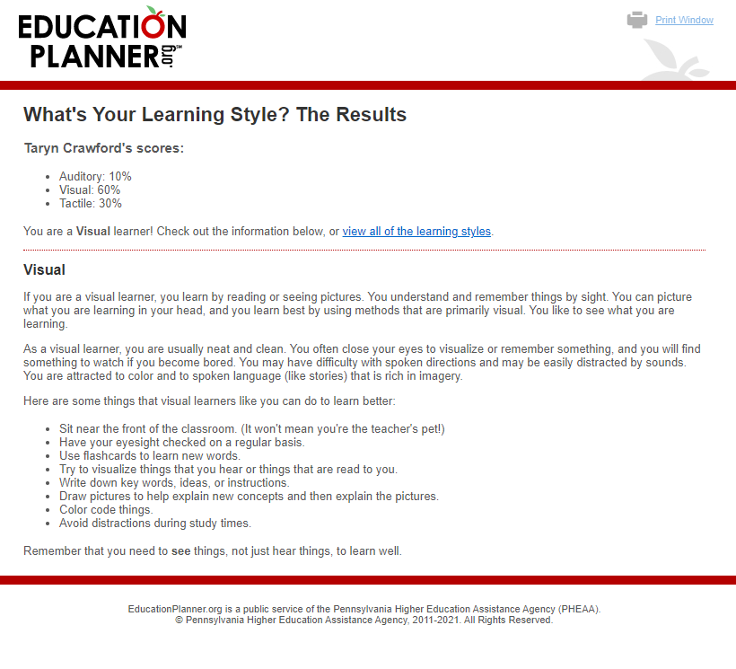 The results ended up matching my expectations. I have always been a very visual individual and using my hands only helps to solidify it. That is most likely the reason why I like to draw out photos or images to match what I am learning, so I can have the physical drawing to look at while using my hands to create it. In this class, I will most likely sketch out ideas for things that I want to create on paper first before diving right in, I will also make sure to write out any code I may need to study. To help me out in this class, video instructions with visuals are very helpful to my learning. It is nice to be able to see what it is I will be doing.